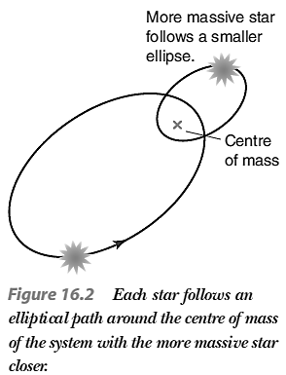**5. The study of binary and variable stars reveals vital information about stars**

***Describe binary stars in terms of the means of their detection: visual, eclipsing, spectroscopic and astrometric***

* A binary star system consists of two stars in orbit about a common centre of mass. In all binary star systems, each star follows an elliptical orbit around the system’s centre of mass, with the star of greater mass tracing out a smaller ellipse.
* Binary systems are classified according to the way that they have been detected, placing them into the following four groups: visual, eclipsing, spectroscopic and astrometric.
  + Always remember, however, that there is no physical difference between any of these binary systems.

*Visual Binaries*

* A visual binary can be resolved as two distinct stars by a suitably large telescope. This means that a visual binary must have an angular separation larger than the resolution of our best telescopes.
  + Also, as a result, visual binaries tend to be systems that are relatively close to Earth.
  + An important thing to consider is that a potential visual binary system must be observed over a period of time (possibly years) for astronomers to be certain the stars are orbiting each other, rather than just being stars that appear close together by being in the same “line of sight”.
* The brightest star of the pair is called the primary and is designated with the letter A. On the other hand, the other star is referred to as the secondary and is denoted by the letter B. For example, Alpha Crucis A and B are classified as a visual binary.

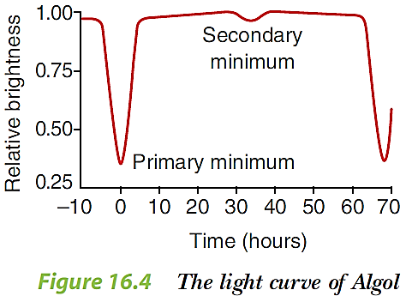*Eclipsing Binaries*

* An eclipsing binary is a binary system whose orbital plane is seen edge on by us, resulting in a variable light output. This means that, at some stage through an orbit, each star periodically eclipses the other and blocks some/all of its light. These binaries are characterised by their light curve, when a graph of brightness versus time is plotted. A typical example is Algol, the first eclipsing binary discovered, whose light curve is shown in figure 16.4.
* Now, let’s look at a hypothetical example of an eclipsing binary. Star A and Star B are together as part of binary star system X. Star A is the smaller yet hotter star while Star B is a bigger yet cooler star.
  + When the stars are side-by-side from our point of view, the system produces maximum light.
  + When Star B is in front of Star A (known as the primary eclipse), the smaller star (A) is entirely hidden and the total light received from the system drops significantly.
  + When Star A is in front of Star B (known as the secondary eclipse), the bigger star (B) is partially hidden and the total light received drops again, but not as much as during the primary eclipse.
* As a result of these variations, the light curve shows a regular pattern of asymmetrical dips, as shown in the diagram below. Consequently, by measuring the time between successive primary (or secondary) minima, we can deduce the period of motion. Furthermore, the duration of the primary and second eclipses can also help us determine the diameter of each star.

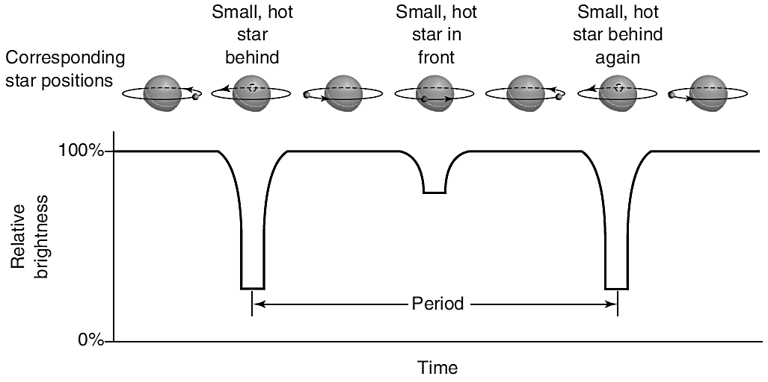

* Note – If an eclipsing binary is edge-on to our line of sight, then the light curve will be straight lines, with flat-bottomed dips. On the other hand, if the our view of the star’s orbits is more oblique, the graph will be more curved in nature, similar to that of Algol (on previous page).
* Note – The periods of most eclipsing binaries are few hours or days.

*Spectroscopic Binaries*

* A spectroscopic binary has its binary nature revealed by periodic yet alternating Doppler shifting of spectral lines. As a result, spectroscopic binaries generally have to be viewed edge on to be detected.
* This alternating Doppler shifting of spectral lines occurs because, as one star of the binary recedes from Earth, the other one approaches. Thus, this results in simultaneous blue and red shifting (which appears as splitting of spectral lines), when the stars’ motion is parallel to the observer’s line of sight. On the other hand, when the motion of the stars is perpendicular to our line of sight, no Doppler shifting occurs.
  + In summary, periodic doubling of spectral lines is an indication of a spectroscopic binary.

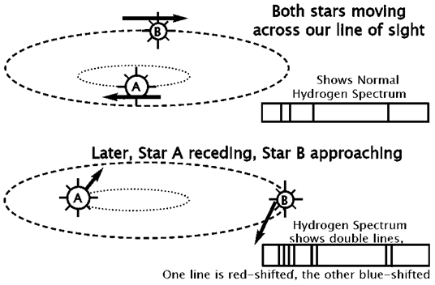

* Astronomers have noticed that spectroscopic detection of a binary system is most likely, if the period of the motion is relatively short and the translational velocity of each star is relatively high. Consequently, spectroscopic binaries tend to be close binary systems.
* Interesting, the majority of known binary systems have been discovered using spectroscopy.

*Astrometric Binaries*

* For a long time, scientists have been able to accurately map the exact position of a star in the night sky. This is important, because stars are not necessarily fixed in regard to their position in the sky. In fact, most stars exhibit some degree of ‘proper motion’ as the move through space.
* Consequently, astrometric binaries are detected by observing a slight ‘wobble’ in a visible star’s position along its path of proper motion. From this observation, astronomers are able to be deduce that such stars are part of a binary, because the only force known that could cause a star to deviate in such a way is gravitational attraction to a nearby, ‘invisible’ companion star.

***Explain the importance of binary stars in determining stellar masses***

* After analysing the motion of binary systems, astronomers can deduce the distance of separation between the two stars as well as the orbital period (T). As a result, by using a modified version of Kepler’s Third Law, we can calculate the total mass of the binary system (M).
* Astronomers use the following equation $M=m_{1}+m_{2}=\frac{4π^{2}r^{3}}{GT^{2}}$, where:
  + M is the total mass of the binary system (i.e. m1 + m2), in kilograms (kg)
  + m1 is the mass of star 1, in kilograms (kg)
  + m2 is the mass of star 2, in kilograms (kg)
  + r is the distance of separation between the two stars, in metres (m)
  + G is the universal gravitational constant = 6.67 × 10-11 N m2 kg-2
  + T is the orbital period of the binary system, in seconds (s)
* By using the equation above, it is possible to calculate the mass of a binary system, but not the individual star masses. In order to do that a measurement must be made of the distance from one of the stars to the centre of mass. This is not an easy measurement to make, since the inclination of the orbit relative to us must be known. However, if this required measurement can be made, then we can determine the mass of each star in the system, by using the formula $m_{1}=\frac{M(r-r_{1})}{r}=M(1-\frac{r_{1}}{r})$, where:
  + m1 is the mass of star 1, in kilograms (kg)
  + M is the total mass of the binary system (i.e. m1 + m2), in kilograms (kg)
  + r is the distance of separation between the two stars, in metres (m)
  + r1 is the distance from star 1 to the centre of mass of the binary system, in metres (m)
* After analysing the motion of binary systems, astronomers can deduce the distance of separation between the two stars as well as the orbital period (T). As a result, by using a modified version of Kepler’s Third Law, we can calculate the total mass of the binary system (M).
* As a result, determining stellar masses can be very useful for astronomers. For example, a knowledge of the masses of stars in different parts of the H-R diagram has been important in reaching an understanding of the processes that occur within a star. This in turn has led to the development of theories about how stars form, evolve and die – which we will delve into the next section of Astrophysics.

***Classify variable stars as either intrinsic or extrinsic and periodic or non-periodic***

* A variable star is a star that appears to vary in brightness.
* A variable star can be classified according to the nature of the cause of its brightness variations (intrinsic/extrinsic). In addition, another way to categorise variable stars is in regard to how brightness variations occur with time (periodic/non-periodic).

*Intrinsic or Extrinsic??*

* An intrinsic variable has its brightness variation caused by changes within the star itself. That is, an intrinsic variable actually experiences changes in its light output
* Our Sun is an example of an intrinsic variable. It has sunspots that are darker than the surrounding surface and these sunspots are not dispersed symmetrically around the Sun. Consequently, as the Sun rotates, an observer on Earth might observe slight variations in the Sun’s luminosity.
* Pulsating variables are another example of intrinsic variables. Such stars are constantly expanding and contracting, with their size, spectral type and luminosity constantly changing as well. These stars are still stable, as they pulsate without exploding or disintegrating.
* On the other hand, an extrinsic variable has its change in brightness caused by any process or event that is external to the star. That is, an external factor changes the amount of light reaching Earth from an extrinsic variable.
* Examples of extrinsic variables include stars of eclipsing binary systems and rotating variables.
  + Rotating variables include any star which has cooler or hotter spots placed irregularly on its surface, hence causing its brightness to change as it rotates.

*Periodic or Non-Periodic??*

* For periodic variables, their brightness changes in a regular, repeated cycle with a fixed period. A good example is Cepheid variables.
* On the other hand, non-periodic variables exhibit irregular variations in brightness with no set pattern. For example, sudden outbursts of energy due to instability results in a star being a non-periodic variable.
* Examples of non-periodic variables are:
  + supernovae (a supernova is a violently exploding star, which may become over a billion times brighter than the Sun, and for many weeks may outshine the entire galaxy in which it lies)
  + flare stars (a flare star is a red dwarf which experiences irregular yet intense outbursts of energy from small areas on its surface)

***Explain the importance of the period-luminosity relationship for determining the distance of cepheids***

* Cepheids are a type of periodic, intrinsic variables. Generally, they are very luminous yellow supergiants.
* 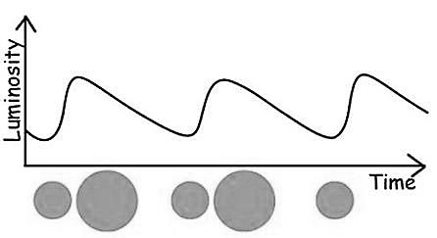Cepheids exhibit light output curves characterised by a rapid brightening phase followed a more gradual dimming phase, and this process repeats. The shape of the light curve is indicative of how the imbalance between gravitational pressure inwards and nuclear pressure outwards changes over time.

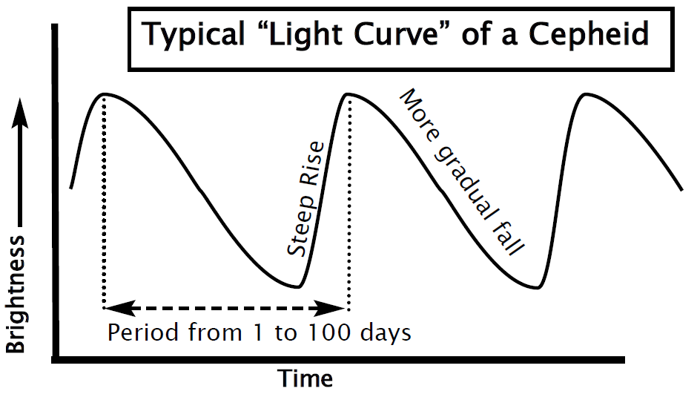

*So where did it all begin?*

* In the early 1900s, Henrietta Levitt (an American astronomer) catalogued over 1700 variable stars in the Small and Large Magellanic Clouds. She discovered that there was a strong correlation between the period of the 47 Cepheids she had catalogued and their luminosities.
* When using a logarithmic (instead of linear) scale for the time axis, a graph like this was obtained:

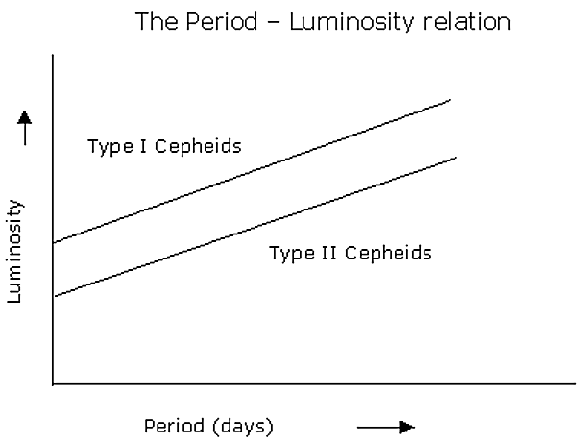

* With such a relationship, astronomers needed to first measure the period of pulsation of a Cepheid variable. Then, by determining whether the Cepheid is type I or II by using spectroscopy, they could determine its luminosity immediately. And then, by comparing the Cepheid’s luminosity with its apparent brightness, we can then calculate the distance to the star. This can be done either by using the inverse square law or by applying absolute and apparent magnitude in the distance modulus equation.
* This then meant that Cepheids can be used as ‘standard candles’ for distance measurement – that is, astronomers could use Cepheids as distance measurement tools. In fact, Cepheid variables are not only observed in our own galaxy, but also in other galaxies well beyond the limits of the usual stellar distance measuring techniques (e.g. parallax). Therefore, if clusters and galaxies have Cepheids in them, the distance to them can be calculated accurately.
* The use of Cepheids in this way then enabled astronomers to estimate (in the early 1900s) to estimate the size of the Universe. In fact, the utilisation of the period-luminosity relationship led to a doubling in the estimated size of the Universe.
* Note – You may be wondering what the difference is between Type I Cepheids and Type 2 Cepheids. It is not important, but for the sake of curiosity here is the difference –
  + Type I Cepheids are generally younger, brighter, larger stars with relatively high metal content, whereas Type II Cepheids are older, dimmer, smaller stars with relatively low metal content.
  + Also, Type II Cepheids are more commonly found in globular clusters.

***Perform an investigation to model the light curves of eclipsing binaries using computer simulation***

* Hmmmm…..

***Solve problems and analyse information by applying: ${ m}_{1}+m_{2}=\frac{4π^{2}r^{3}}{GT^{2}}$***

* The formula $M=m_{1}+m_{2}=\frac{4π^{2}r^{3}}{GT^{2}}$ was introduced in a previous dot-point.
* Here are some example questions:
* *Example Q* 🡺
  + **Question** 🡪 A binary system is observed to have a period of 28 years. The two stars are separated by a distance of 2.5 x 109 kilometres. Calculate the total mass of the 2 stars in the binary system.
  + **Solution** 🡪
    - * Now, period is in years, but we have to convert it to seconds. Also, distance of separation is in kilometres, but we have to convert it to metres.
$m_{1}+m_{2}=\frac{4π^{2}{(2.5×{10}^{9}×1000)}^{3}}{(6.67×{10}^{-11})×{(28×365.25×24×60×60)}^{2}}$

$m_{1}+m_{2}=1.18×{10}^{31} kilograms (to 2 d.p.)$

* Note – Say we used solar masses as the units for mass, astronomical units (AU) for distance and Earth years for period. Then what actually happens is that formula simplifies down to $m_{1}+m_{2}=\frac{r^{3}}{T^{2}}$ Neat!
* *Example Q* 🡺
  + **Question** 🡪 A binary system is observed to have a period of 3.5 years and a separation distance of 2.7 astronomical units. Also, the mass of the larger star is estimated as being 7.5 x 1030 kilograms. If the Sun’s mass is 6 x 1030 kilograms, what is the mass of the smaller star?
  + **Solution** 🡪